Attorney
BD Howard Jr.
Attorney BD Howard Jr. holds a BS Degree in Sociology and Political Science from Texas A&M University-Commerce, 1971. He has a Juris Doctor Degree from Texas Southern University School of Law, 1974. Legal Organizations includes the following: State Bar of Texas, Dallas Bar Association,
JT Turner Legal Association, Dallas Criminal Defense Lawyers Association and the Texas Criminal Defense Lawyers Association.

The seminar topics he will cover are as follows:

- Dallas County Criminal Justice System
- What to do when a person has been arrested in Dallas County, Texas
- What is the purpose of posting a bond
- What is the difference between a misdemeanor offense and a felony offense
- What is an expunction
- Crimes involving moral Turpitude
- Parole eligibility from prison

Judge
Tonya Parker
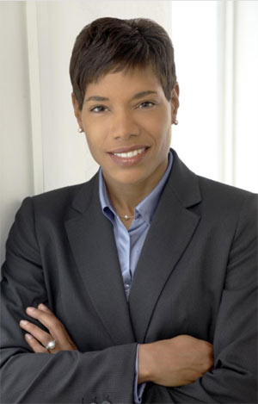
Judge Tonya Parker was elected in 2010 to serve as the Presiding Judge of the 116th Civil District Court in Dallas County, Texas.
She received her undergraduate degree in Communications Studies from the University of North Texas, and her Juris Doctorate from Southern Methodist University Dedman School of Law.

The seminar topics she will cover are as follows:

- Jury Service
- Avoiding Default Judgment
- Changes in Texas Law
- (Foreclosure Actions)

Legal Seminar
Sponsored by
the Garland Branch
NAACP
Tuesday, July 23, 2013
@ 7:00 p.m.

WOMEN’S
ACTIVITY CENTER
713 Austin Street
Garland, TX 75040
(Refreshments will be served)
Attorney
Shaun Naidoo
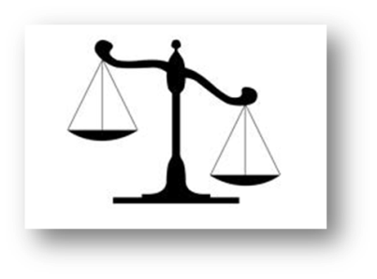
The Naidoo Law Firm
was started in May 2005 by Attorney Shaun C. Naidoo.
For his undergraduate studies, Shaun attended Texas A&M University at Commerce, and graduated in May 2001.
Shortly thereafter, in 2004,
he graduated from Texas Wesleyan School of Law with his Juris Doctor degree.

The seminar topics he will cover are as follows:

- Child Support: Consequences if unpaid
- Child Custody
- The Consequences of Unpaid Child Support
- Traffic Tickets:
- The repercussions of running a toll, not paying tickets, and any possible registration restrictions
- Nondisclosures
- and Expunctions:
- What they are, who is eligible for them, and who is not
- Car Accidents:
- Why it is important to get an attorney and the truth behind dealing with the insurance companies.

Note:
This presentation will be of interest to those 16 years and up.

